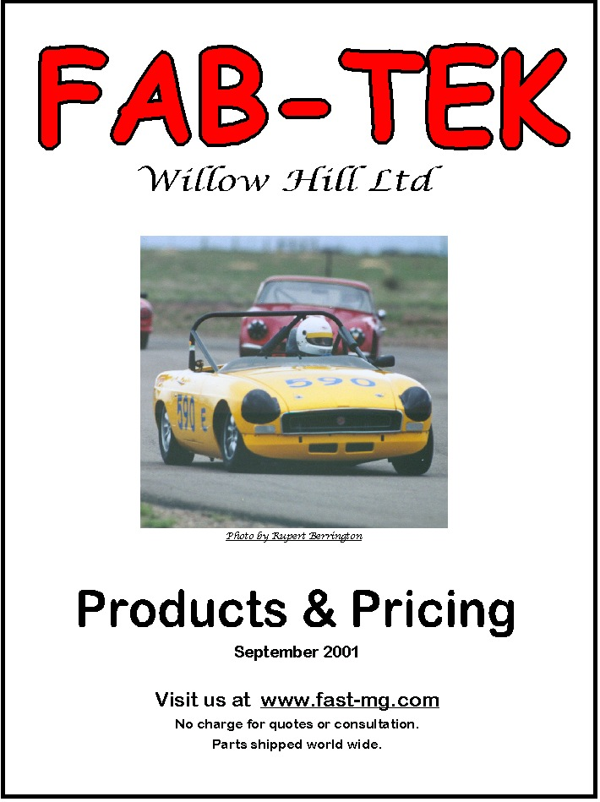
January 2010

DISCLAIMER
All FAB-TEK products & services are sold for off-road use only. Due to the intended off-road use & because FAB-TEK Willow Hill Ltd cannot control how parts are installed, serviced or used, there are no guarantees or warranties.

Racing is an inherently dangerous activity & should only be done by trained & skilled participants under supervised & controlled conditions. FAB-TEK Willow Hill Ltd accepts no responsibility for injuries sustained while using its products.

Meet . . .

Dave Headley, mastermind of FAB-TEK

A degreed & practicing Mechanical Engineer for 35 years at General Motors, involved in engine development including the Quad 4, Ecotech 4 & Vortec In-Line 6.

Racing in SCCA since 1965, mostly with E-Production MGB’s, but also ran Brabham & Brabota Sports Racers.

He was the 1990 SCCA National Champion with a Showroom Stock Quad-4 powered Oldsmobile Calais.

Visit our website at www.fast-mg.com for more information & our race schedule.

FAB-TEK PRODUCTS & PRICING

RACE ENGINES
FAB-TEK race engines feature cylinder heads with fast burn-rate chambers & outstanding airflow for best-in-class power & torque. I use the latest piston & ring technology with Carrillo rods & heat-treated cranks for excellent durability.
Prices for new engine builds start at $ 2,750* plus purchased parts & services.
Rebuilds start at $ 1,250 plus purchased parts & services.
Initial teardown analysis is $ 250.
Quotes are free.

RACE HEADS
Feature fast burn chambers & excellent air flow. I only use premium light weight stainless valves, custom made manganese-bronze guides, titanium retainers & Isky springs.
A complete turnkey head is $ 1,695*. Domed chambers - add $150.
Prices start at $ 1,000 using all customer supplied components.
Also see manifolds.

RACING VALVE JOBS
Including bowl blending
Price: $ 175

HARD VALVE SEATS INSTALLED
- by the shrink fit method
Price: $ 135

VALVE TRAIN COMPONENTS
- SPRINGS, $ 120 per set
- TITANIUM RETAINERS, $ 175 per set
- Mn-bronze guides, $ 175 per set
- STAINLESS RACE VALVES, up to 1.72”/1.45” diameter, $ 200 per set

RACE CAMS
FAB-TEK offers three standard camshaft lobe variations, plus additional timing variants (other custom grinds can be specified for your application at the same price)
Full race for use with hi-lift rockers
Full race for use with stock rockers
Vintage for use with any rockers.
Price: $ 265* including lifters.

HI-LIFT ROCKER ARMS
The FAB-TEK racing rocker arms are 1.6:1 ratio. They are a light-weight steel design with needle bearing pivot & correctly contoured radius tip. They provide unmatched strength, durability & REDUCED reciprocating weight compared to available aluminum rocker arms.
They require an adapter to be installed on your head by FAB-TEK & an oiling system in the rocker cover both installed by FAB-TEK. They also require adjustable push rods.
Price: $ 495 – includes mounting on your head & reworked standard rocker cover. Aluminum covers - add $ 50.
- plus pushrods for $ 90 a set

RACING PUSHRODS
FAB-TEK chrome-moly pushrods are 3/8” diameter for improved stiffness. Available as stock replacement or adjustable for use with FAB-TEK rockers.
Price: $ 90 – set of 8, any length.

1 3/4" S.U. CARBURETORS
Race prepped & mounted on original (modified) twin carb manifold with air horns.
Price: $ 495* plus purchased parts

WEBER DCOE CONVERSIONS
Available in 45mm or 48mm DCOE. Your carburetor set up with appropriate calibration for MGB.
Price: $ 145 Ask about cable adaptors.

INTAKE MANIFOLDS
Your S.U. manifold filled & ported to match your head - $ 175
Your Weber manifold ported to match your head - $ 175
- $ 275 if welding/filling required
Standard DCOE 130 manifold (unported) - $ 175

RACING EXHAUST HEADER SYSTEM
Custom built for maximum top end power. 3 into 1 design with merge collector. Better than Tri-Y system above 6000 rpm.
Price: $ 645 with exhaust - pipe

RACING OIL PANS
FAB-TEK fabricates oil pans featuring excellent windage control & surge baffling without sacrificing ground clearance.
Price:
- wet sump $ 375*
- dry sump $ 425*
DRY SUMP OILING SYSTEMS
Featuring the efficient & reliable TDC gerotor oil pumps in either 1, 2 or 3 stage.
Prices:
1-stage pump $ 425 (wet sump-external pump)
2-stage pump $ 525
3-stage pump $ 625
Pump mounting brackets $ 150
Belt drive $ 175
AeroQuip scavenge hoses $ 75 each
Scavenge manifold $ 125

BRONZE OIL PUMP DRIVE GEAR - $ 145

OIL FILTER BLANKING PLATE
Provides up to 3 ports for plumbing oil coolers & remote mount filters.
Price: $ 90

ALUMINUM ENGINE BACK PLATES - $ 195

ALUMINUM FLYWHEELS - $ 395

TILTON CLUTCH
- PP $ 385
- DISC $ 85

HYDRA CLUTCH
– concentric slave cylinder actuator kit - $ 345

ALUMINUM RADIATOR & INSTALLATION KITS
Requires slight rework to stock shroud.
Prices:
Radiator $ 495
Installation Kit (hoses, brackets, etc) $ 125
Should be used with remote surge tank but can be supplied with filler on radiator.

CARBON METALLIC BRAKE SHOES - $ 195 plus core

REAR DISC BRAKE CONVERSION KITS
SCCA legal. Utilizes solid rotor with Wilwood Dynalite single caliper. Specify banjo or tube style axle housing.
Price: $ 595
WELDED SPIDER-GEAR (locked) DIFFERENTIAL
Customers 3rd member cleaned, inspected & differential pinions welded to lock differential (spool type).
Price: $ 145 (Request quote for setting up a new ring & pinion.)

RE-ALIGNED BANJO AXLE HOUSING
Stock factory housings are usually toed out which creates erratic handling. I can re-align your axle housing to provide up to 1/16 inch toe-in & 3/4 degree negative camber. (no cutting or welding)
Price: $ 195

BANJO AXLE HOUSING
converted to use tube axle bearings, brakes & shafts.
Price: $ 275

AXLE LOCATOR KITS
The FAB-TEK axle locator kit provides simple low cost lateral axle location on lowered cars. The system is symmetrical & provides consistent handling in right & left turns (unlike a panhard bar)
Price: $ 145

FAST RESPONSE TRACTION BARS
These bars are designed to create an axle steer affect during cornering which eliminates roll oversteer & dramatically increases forward bite when accelerating out of corners.
Price: $ 325*

DROPPED FRONT SPINDLES
I will rework your spindles to lower the car one (1) inch. Also raises roll center & adds camber gain. Includes new king pin bushings reamed to size.
Price $ 325*

LOWERING BLOCKS
FAB-TEK lowering blocks are ¼ inch thick & are used in stacks up to 1” total. This allows adjustability for setting corner weights.
Price: $ 10 each
$ 75 set of 8
REWORKED LEAF SPRINGS
The MGB rear spring can be softened by removing a leaf & restacking the remaining leaves. This will reduce rear spring rate (good) & lower the car about 1”, further lowering can be achieved by de-arching the leafs.
Prices:
Restacked minus 1 leaf: $ 75 each*
Restacked & de-arched $ 125 each*
Notes: A cleaning charge will be added for springs with excessive dirt & rust.

TUBULAR FRONT SWAY BAR KIT
Includes mount blocks & linkage. 1” o.d. equivalent to 15/16” solid bar.
Price: $ 375 (includes mounting hardware)

ADJUSTABLE REAR SWAY BAR
Desirable to improve handling balance with large front sway bars: 1/2" or 5/8”
Price: $ 325 (includes mounting hardware)

Please see PREMIUM RACE ENGINE COMPONENTS on following page
PREMIUM RACE ENGINE COMPONENTS
For the do-it-yourself race engine builder.

The following major components can be custom ordered to meet your needs.

PISTON & RING SETS
FAB-TEK has established an excellent ring source for racing. A forged piston design is available to utilize these rings which come in .25mm size increments. For example, 81.25mm bore diameter is 3.1988 inch, which is .040 over standard MGB. The FAB-TEK piston features lowered top ring position for clearance to exhaust valve notches. Piston sets include 4 pistons, rings, pins & retainers.
Price: $ 645

CONNECTING RODS
The FAB-TEK Carrillo rod is designed to utilize Clevite 77 bearings, which are 3mm wider than normal MGB (5-main) rod bearings. These bearings are superior to other MGB bearings because of the added width. However, they only come in sizes of .005 & .015 undersize. The rods are made by Carrillo to FAB-TEK specs for these bearings. These special bearings are readily available from FAB-TEK & many automotive parts stores.
Price: $ 1,350 – set of 4 rods – 5main – Quad4 bearings

CARRILLO RODS
are also available for standard width bearings.
Price: $ 945 (SPS bolts)
$ 1150 (Carr bolts)

RACE CRANK PREP
- freeze temper $ 175
- grind, polish, balance $ TBD
- Aero-machine counter weights $ 495

PAYEN HEAD GASKETS
Provide superior compression sealing on high compression ratio (up to 16:1) engines.
Price: $ 45
Note: Cometic MLS head gaskets have been tested with unsatisfactory results. Inquire!

HIGH STRENGTH CYLINDER HEAD STUDS & NUTS
Made by ARP, the fasteners allow higher head nut torque to improve gasket sealing. Price: $ 145 a set

OTHER ITEMS
In addition to the many standard items listed previously, FAB-TEK can provide a variety of other custom ordered or fabricated parts for your racing MG. If you don’t see it here, please ask. I take pride in providing services & parts in a timely manner. If I cannot do your job promptly, I will inform you up front.

I appreciate your business.
Sincerely,
Dave Headley

